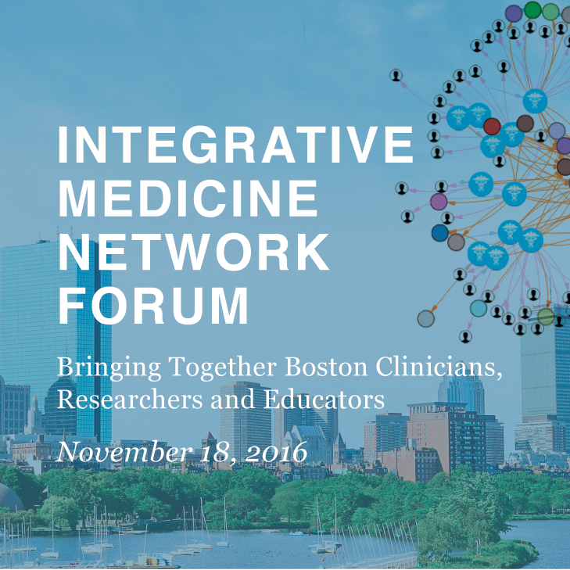
Research Abstract Application Form
Integrative Medicine Network Forum, Half-Day Symposium: 8:00am – 2:00pm
Joseph B. Martin Conference Center, Harvard Medical School, Boston, MA

The Osher Center for Integrative Medicine at Harvard Medical School and Brigham and Women’s Hospital invites the submission of research abstracts related to Integrative Medicine (IM). These will be for presentation at the Integrative Medicine Network Forum at Harvard Medical School on Friday, November 18th, 2016.

The IM Network Forum will convene Boston-area researchers, educators and clinicians with interests in Integrative Medicine to meet, share ideas and explore future collaborations.

Up to 40 research abstracts will be chosen for poster presentation. Additionally, 10 selected poster presenters will be invited to give a 1-minute “elevator pitch” oral synopsis of their work in the plenary session.
- Read Research Abstract Submission Guidelines Here
- Abstract Submission: Send this form by email to Aterah Nusrat at anusrat1@partners.org
- Submission Deadline: 12:00am (Midnight), Friday, September 30th, 2016
- Accepted Abstracts Announced: Monday, October 17th, 2016

1) Presenting Author Information
Author Name:
Position:
Institution:
Email address:

2) Additional Author Information
Repeat the above entry format for each successive author: Name; Position; Institution; Email Address.
(Note: The order in which you list additional authors will be the order in which they appear in the IM Network Forum program.)

3) Title of Abstract
The title must be entered in title case. (First word initial Capital, capitals only for ACRONYMS and first letter of a Proper Noun). Please do not use all capitals in the title. Titles are limited to 100 characters including spaces, punctuation and should indicate the content of your abstract.

4) Content of Abstracts
The content of abstracts should be structured as follows: Purpose, Methods, Results, and Conclusion.
Your submission (excluding the abstract title) is limited to 350 words.

